Hardware And Components

Assignment Day-5

Task-1: List all the main components you find inside a desktop PC after opening the cabinet, and write a short description (1-2 lines) for each.

Component | Short Description
Motherboard | The main circuit board that connects and allows communication between all the components of the computer.
CPU (Processor) | Acts as the brain of the computer and processes instructions and calculations.
RAM | Temporary memory that stores data and programs currently being used by the computer.
Hard Disk Drive (HDD) | A storage device that stores the operating system, applications, documents, videos, and other files.
SSD | A faster storage device that uses flash memory and helps the computer boot and load applications quickly.
GPU (Graphics Card) | Processes and displays images, videos, and graphics, especially for gaming and editing.
Power Supply Unit (PSU) | Converts electricity from the wall outlet into the required power for different PC components.
CPU Cooler | Removes heat produced by the CPU and prevents it from overheating.
Cabinet/Case Fans | Circulate air inside the cabinet to keep the internal components cool.
Optical Drive | Used to read or write CDs and DVDs; mostly found in older desktop computers.
CMOS Battery | A small battery that helps maintain the system clock and BIOS/UEFI settings when the PC is switched off.
Expansion Cards | Additional cards, such as sound, Wi-Fi, or network cards, that add extra features to the computer.
SATA Cables | Connect SATA storage devices such as HDDs and SSDs to the motherboard.
Power Cables | Carry electrical power from the PSU to components such as the motherboard, drives, and graphics card.

Task-2: Take clear photos or draw labeled diagrams of each step as you disassemble a desktop PC, and organize them in a document with captions explaining what you did at each step.<br><br><em><strong>Hint:</strong> Include steps like unplugging power, removing side panel, disconnecting cables, and removing RAM, HDD/SSD, and motherboard.</em>.

STEP1-Switched off the computer and disconnected the power cable before opening the cabinet.
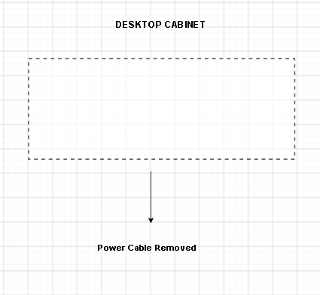

STEP2-Removed the side cabinet to access internal hardware components.

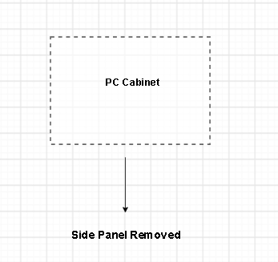

STEP3-Disconnected all power and data cables before removing components.
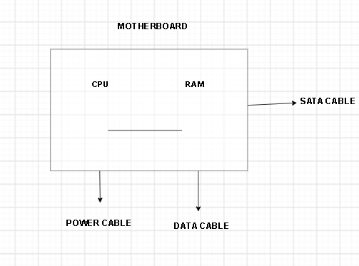

STEP4- Opened the retaining clips and carefully removed the RAM module.
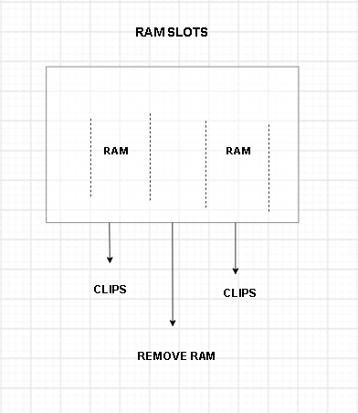

STEP5- Disconnected SATA cables and removed the storage drive.
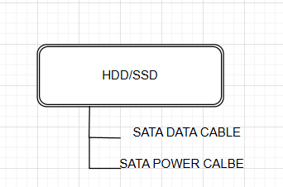

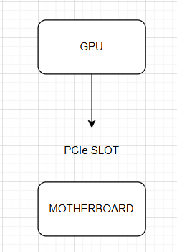
STEP6- Removed PCIe power cable and carefully pulled the graphics card from the PCIe slot.

STEP7- Removed the CPU cooler assembly to access the processor.
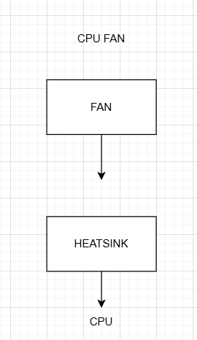

STEP8- Removed motherboard mounting screws and carefully lifted the motherboard out of the cabinet.
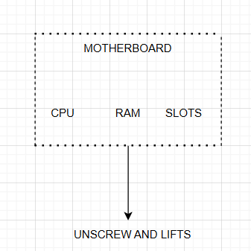

Task-3: Reassemble the PC you disassembled, documenting each step with a brief explanation of what you connected or installed and why the order matters.
1. Install the Motherboard
- Place the motherboard inside the cabinet and secure it properly with screws.
- It is installed first because most other components are connected directly to it.
2. Install the CPU
- Carefully place the CPU into the correct CPU socket and lock it in place.
- The CPU is installed before the cooler and other components for easier access.
3. Install the CPU Cooler
- Place the CPU cooler over the processor and connect its fan cable to the motherboard.
- It helps keep the CPU at a safe temperature while the PC is running.
4. Install the RAM
- Insert the RAM sticks into the correct DIMM slots until the side clips lock them in place.
- Installing RAM at this stage makes it easier to access and check before closing the cabinet.
5. Install the GPU
- Insert the graphics card into the PCIe x16 slot and secure it to the cabinet.
- The GPU handles graphics processing and is important for gaming and other graphics-heavy tasks.
6. Install the HDD/SSD
- Place the storage drive in its proper position and connect the SATA data and power cables.
- These connections allow the computer to access the operating system, applications, and stored files.
7. Connect Power Cables
- Connect the 24-pin motherboard power cable and CPU power cable from the PSU.
- These cables provide the required power to the motherboard and processor.
8. Connect Other Cables
- Reconnect the front-panel, USB, audio, and cabinet fan cables to their respective motherboard headers.
- Correct connections ensure that the cabinet buttons, ports, and fans work properly.
9. Close the Cabinet and Test
- Replace the side panel, connect the external cables, and switch on the PC.
- Check that the computer starts normally and all components are working properly.

Task-4: Create a checklist of safety precautions and tools needed before starting the PC assembly/disassembly process, and explain why each is important.
Tools Needed
Tool | Why it is important
Phillips-head screwdriver | Used to remove and tighten most screws inside the PC cabinet.
Anti-static wrist strap | Helps prevent static electricity from damaging sensitive components.
Small container for screws | Keeps screws organized and prevents them from getting lost.
Soft, clean cloth | Useful for cleaning dust and handling components safely.
Compressed air | Helps remove dust from fans, heatsinks, and other components.
Cable ties | Used to organize cables and improve airflow inside the cabinet.

Safety Precautions

Safety Precaution | Why it is important
Switch off and unplug the PC | Prevents electric shock and protects the components from electrical damage.
Work on a clean, dry surface | Prevents dust, moisture, and accidental damage to the components.
Remove all external cables | Makes the PC safer and easier to work on.
Use an anti-static wrist strap | Prevents electrostatic discharge (ESD), which can damage electronic components.
Handle components by their edges | Prevents fingerprints, dirt, and accidental damage to delicate contacts or circuits.
Do not force any component | Components should fit into their slots correctly; forcing them can damage the motherboard or connectors.
Keep screws and small parts organized | Prevents losing parts and using the wrong screw during reassembly.
Check connections before powering on | Ensures cables and components are properly installed and reduces the risk of damage.
Keep liquids away from the PC | Water or other liquids can cause short circuits and permanently damage components.
Ground yourself before touching components | Reduces the chance of static electricity being transferred to sensitive hardware.

